Title — Author Guidelines for Paper Submission to GeoQuébec 2026  Author One, Author Two & Author Three  Company Name, City, Province/State, Country  Author Four & Author Five  Department of XX – University of YY, City, Province/State, Country | 

ABSTRACT
Papers submitted to the conference proceedings will be accepted in either English or French, based on the abstract provided. The presenting author, who does not have to be the first author, must register as a full conference participant to submit the final manuscript. Each registered presenter may deliver a maximum of two papers per paid registration. All manuscripts must be prepared electronically and submitted according to the following guidelines, using the online submission system available on the conference website: www.geoquebec2026.ca

RÉSUMÉ
Les articles destinés aux actes de la conférence sont acceptés, en anglais ou en français, sur la base du résumé soumis. Pour déposer la version finale d’un manuscrit, l’auteur présentateur, qui n’est pas nécessairement le premier auteur, doit être inscrit comme participant pour l’ensemble de la conférence. Chaque présentateur peut soumettre un maximum de deux articles par inscription payée. Tous les manuscrits doivent être préparés en format électronique et soumis conformément aux directives ci-dessous, au moyen du système de soumission en ligne disponible sur le site Web de la conférence : www.geoquebec2026.ca/fr

PAPER PREPARATION GUIDELINES

These instructions are based on the official technical paper template, which illustrates the correct format for manuscript preparation. The template is available in the Submission Details section of the conference website.
Papers may be submitted in either English or French; however, abstracts must be provided in both official languages.
This document uses bold and italics to highlight certain elements, but this formatting should not appear in your document.

Publication Quality and Uniformity

To ensure quality and consistency across all conference papers, authors must carefully follow these guidelines. Papers that do not comply will be returned for revision and resubmission. Delays in resubmission may result in the paper being excluded from the Conference Proceedings.
The easiest way to comply is to use the official template provided on the Submission Details page of the conference website.

Required Registration

Each presenting author must register as a full conference delegate (or student, if applicable) before submitting the final paper. Registration must be completed through the conference website at www.geoquebec2026.ca
If you have not registered before uploading your paper, the online submission system will prompt you to do so.

Online Submission

All papers must be submitted online by June 26, 2026, using the online submission feature on the conference website – emailed submissions will not be accepted. The corresponding authors of accepted abstracts can access the paper submission feature by logging in using their Username and Password registered during the abstract submission process.
Please ensure that your document meets the formatting guidelines before submitting. Please submit your file as a Word document.

Length

The normal length of a complete paper, including title, abstracts, text, figures, photographs, tables, acknowledgments, and references, is SIX (6) to EIGHT (8) pages. Papers longer than eight (8) pages in length will be accepted at the discretion of the Technical Committee.
The combined length of both abstracts (total) should not exceed 300 words.

Font

All text must be 9-point Arial font with the following exceptions:

- The title must be 14-point bold. Bold font face should not be used anywhere else in the paper
- Authors’ names should be in 10-point Arial font
- The affiliation, city, province/state, and country must be in a 10-point Arial Italic font.
- Use an italic font for ‘quoted text’, and to identify the source in the list of references.

Page Size and Margins

The supplied MS Word template has been formatted per this document. If you are not using MS Word, please select “letter” paper size (215.9 mm by 279.4 mm / 8½ inch by 11 inch) and portrait orientation – A4 format is not acceptable. Please set your page for the following margin dimensions: top - 25 mm, bottom - 25 mm, left - 20 mm, right - 20 mm, and gutter - 6 mm. The header and footer settings should both be set at 0 mm from the edge.

Page Numbers

Do not insert page numbers, headers, or footers. These will be added when the proceedings are assembled.

Spacing and Indenting

All text elements should be single-spaced. Text should be in two (2) columns of equal width (81.8 mm) with 6 mm spacing between the columns.
The first paragraph in a section is not indented (use style Normal) – all subsequent paragraphs are indented 5 mm (style Paragraph-regular). There should be no line spacing between paragraphs. The text should be right and left justified.
Leave two (2) open lines above and one (1) open line beneath primary headings - leave one (1) open line above and one (1) open line beneath secondary and tertiary headings.
Leave two (2) open lines between equations and text, and between successive equations. Leave two (2) open lines between the body of text and figures or tables (including captions).
If there is a discrepancy between the template and these instructions, the instructions take precedence.

Conference Logo

The GeoQuébec 2026 conference logo has been placed at the top right corner of the first page (only). It is sized 2 cm high x 5.31 cm wide and is positioned 2 cm below the edge of the page and 14 cm from the left edge.

Title/Author(s)

The full paper title should be typed at the top of the first page in 14-point bold using sentence case and left justified. Leave one (1) line space below the title.
The author’s name(s) should be typed left justified below the paper title. Authors from the same institution may be grouped. Affiliation and country should then be typed in 10-point Italic font (do not leave lines between the names of the authors and their affiliations).
Please insert two (2) open lines after entering the last author’s affiliation.

Abstracts

Each paper must begin with abstracts in both English and French – the total word length of both abstracts (combined) should not exceed 300 words.
Type the word ABSTRACT and then the English abstract, which should run the width of both columns. Leave one (1) open line and repeat with the French version of the abstract preceded by the word RÉSUMÉ.
Leave three (3) open lines between the abstract and the body of the text.

Number Headings

Within the paper, number all headings as follows:
1 PRIMARY HEADING
1.1 Secondary Heading
1.1.1 Tertiary Heading

Tables

Number tables consecutively in order of appearance and locate them close to the first reference to them in the text. Refer to tables as Table 1 or Tables 1 and 2, in the body of the text. Avoid abbreviations in column headings (other than units).
Type the caption above the table to the same width as the table and leave one (1) open line between the table caption and the table. Indicate units in the line immediately below the heading.
Use the same table format as it appears in the Canadian Geotechnical Journal. Use the following example for the format of table.

Table 1. Characteristics of tested soils

Characteristics (%) | Vancouver | Ottawa
Organic matter | 0 | 1
Water content¹ | 40 | 60
Liquid limit | 22 | 44
Plastic limit | 15 | 18
Sand | 35 | 8
Silt | 45 | 44
Clay | 20 | 48
¹water content of specimens after preparation

Equations, Formulas, Symbols and Units

Type equations and formulas from the left of the column (do not center in the column) and number them consecutively. Equation numbers should be placed flush at the right column margin in square brackets.
Refer to equations in the body of the text by these numbers (e.g., "Eq. 1" or "Equation 1 shows..."). Symbols should conform to those recommended by the Metric Subcommittee of the Canadian Geotechnical Society (see Canadian Geotechnical Journal 1980, 17:89-96).

Example of equation:

τ = σ tan φ + c [1]

Illustrations

All illustrations must be embedded in the document. Please resize the inserted object to the desired final dimensions before inserting in the document in order to minimize the file size of the final document.
Please number illustrations (whether drawings or photographs) consecutively in the order of appearance and refer to them as Figure 1, Figures 2 to 4, etc.
Illustrations may be two (2) columns wide or one (1) column wide. Do not place illustrations sideways on a page; however, if this cannot be avoided, no other text should appear on that page.
Under no circumstance is it acceptable to change the orientation of any page to “Landscape” to accommodate an illustration or exhibit – these pages will not output properly when the proceedings or an individual paper is printed.
Drawings may be in color since papers will only be published in electronic format.
Lettering should be approximately the same size as the text with a minimum of 2 mm. Lines should preferably be 0.2 mm thick. Captions should be placed immediately below the illustration.

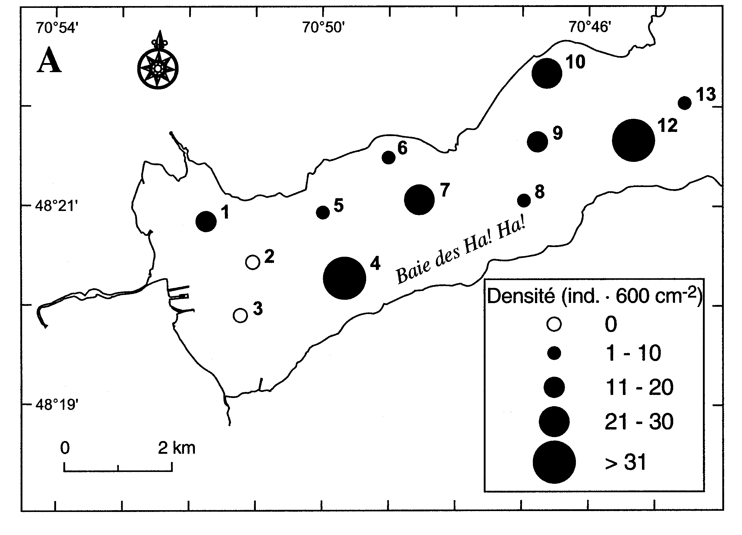Figure 1. Spatial distribution of the macro-benthic organisms (from Pelletier et al. 1999)

References

The conference will follow the current practice of the Canadian Geotechnical Journal for references.
Within the body of the text, references should be made in parenthesis with the author’s surname(s) and the year of publication such as “(Seed et al. 1977)” or “According to Seed et al. (1977)…”
At the end of the paper, list all references in alphabetical order of authors’ names. The first line of each entry in the reference list should not be indented: the following lines should have a 5 mm indent (use style References). Do not leave an open line between references. Type book titles and the names of journals, reports and conferences, etc. in italics.
Format for books is: Last name, Initials. Year. Book title, Publisher, City, State/Province, Country (of publisher). For example:

Terzaghi, K. and Peck, R.B. 1987. Soil Mechanics in Engineering Practice, 2nd ed., McGraw Hill, New York, NY, USA.

Format for journal papers is: Last name, Initials. Year. Article title, Name of Journal, volume number in Arabic numerals, pages. For example:

Ingold, T.S. and Miller, K.S. 1983. Drained Axisymmetric Loading of Reinforced Clay, Journal of Geotechnical Engineering, ASCE, 109: 883-898.

Format for conference papers is: Last name, Initials. Year. Article title, Name of Conference, Publisher, City, State/Province and Country where conference took place, volume number in Arabic numerals: pages. For example:

Leshchinsky, D. and Perry, E.B. 1987. A Design Procedure for Geotextile Reinforced Walls, Geosynthetics ‘87, IFAI, New Orleans, LA, USA, 1: 95-107.

If an issue number is needed to uniquely identify the paper, the issue number should be included following the volume in parenthesis. For example:

Ingold, T.S. and Miller, K.S. 1983. Drained Axisymmetric Loading of Reinforced Clay, Journal of Geotechnical Engineering, ASCE, 109(3): 883-898.

Clearances

All authors are responsible for obtaining written permission to profile the project or subject matter in their papers from any clients, owners, or others who commissioned the work.
The CGS and IAH-CNC assume that you have obtained the proper permission(s) as well as the permission of the coauthors and assume no liability for failure by the author(s) to do so.
The corresponding author must read and accept (by selecting yes) the conditions of release and publication authorization during the online submission process.

Copyrighted Material

If a figure, table, or photograph has been published previously, authors must obtain written approval from the original publisher for it to be reprinted in the conference proceedings.
The source of previously published material should be included in the caption of the table, figure, or photograph.
Authors of papers do not transfer their copyright to GeoQuébec 2026 but only provide permission for the conference to reproduce the paper(s) for the proceedings. Therefore, authors can still submit their paper(s), in original (or revised form), for publication in a scientific journal.

Commercialism

All commercialism must be avoided. Products should be defined by their properties. Product names can only be used once within the paper and only where they are associated with the definition of the properties. Papers that do not conform will be returned to the author to be revised.
Providing an acknowledgment of sponsorship at the end of a paper is both appropriate and acceptable.

5. Paper Submission

All final manuscripts must be submitted electronically in PDF format, or as a file that can be opened using Adobe Acrobat, using the online submission feature available on the GeoQuébec 2026 conference web site at www.geoquebec2026.ca.
Submitted manuscripts must not be password protected.
Authors of accepted abstracts can access the paper submission feature by logging in using their User Name and Password registered during the abstract submission process.
Initial submission of all manuscripts must be completed by June 26, 2026 to be considered.
The online submission process will prompt corresponding authors to register for the conference as a full delegate (or student, if applicable). The paper submission process cannot be completed without the registration process.
For complete details on the manuscript/presentation guidelines, please visit the conference website at: www.geoquebec2026.ca/call-for-abstracts.

